Article

Spatial and temporal variability in spat settlement of intertidal oyster reefs support site-specific assessments for restoration practices

Shannon D. Kimmel1, Hans J. Prevost1, Alexandria Knoell1, Pamela Marcum2 and Nicole Dix 1,*

|  |
| --- |
| **Citation:** To be added by editorial staff during production.  Academic Editor: Firstname Lastname  Received: date  Revised: date  Accepted: date  Published: date    **Copyright:** © 2024 by the authors. Submitted for possible open access publication under the terms and conditions of the Creative Commons Attribution (CC BY) license (https://creativecommons.org/licenses/by/4.0/). |

1 Guana Tolomato Matanzas National Estuarine Research Reserve, Ponte Vedra Beach, FL 32082, USA;   
[Shannon.Dunnigan@FloridaDEP.gov](mailto:Shannon.Dunnigan@dep.state.fl.us) (S.D.K); [Hans.Prevost@FloridaDEP.gov](mailto:Hans.Prevost@dep.state.fl.us) (H.P.); [AKnoell@hotmail.com](mailto:AKnoell@hotmail.com) (A.K.)

2 South Carolina Department of Natural Resources, Charleston, SC 29412, USA; [MarcumP@dnr.sc.gov](mailto:MarcumP@dnr.sc.gov)

**\*** Correspondence: [Nikki.Dix@FloridaDEP.gov](mailto:Nikki.Dix@dep.state.us)

**Abstract:** As some of the most productive ecosystems in the world, the declining condition and coverage of coastal habitats consequently results in the loss of the myriad economic and ecosystem services they provide. Mitigation efforts to address these deficits have been initiated in many places worldwide. Due to variability in physical and biological characteristics across sites , increased place-based information to inform local management projects with the goals of reestablishing economic and ecological function of coastal habitats are imperative. Since oysters are often used in many restoration projects, this study quantified spatial and temporal patterns in eastern oyster spat settlement in a bar-built estuary in northeast Florida, USA that is host to a robust population of intertidal oyster reefs. Understanding how spat settlement varies in a dynamic region with two inlets and a short residence time is valuable for projects seeking to use this species behavior of gregarious settlement in establishing functional oyster reefs as part of restoration projects. There is variability in spat settlement in different regions of the area in which higher counts often coincide to watersheds with higher residence times and years with _____ conditions.

**Keywords:** water quality, living shorelines, *Crassostrea virginica*, management, recruitment

1. Introduction

Coastal ecosystems are some of the most productive in the world providing numerous ecosystem services such as carbon sequestration, improvement of water quality, erosion control, and recreation (Brown et al., 2006; Barbier, 2007). Recognizing their value and aesthetic, these ecosystems are subject to constant human activity which has ultimately led to the steady deterioration in many habitats (estimated anywhere between 30 – 85% loss) of these systems (Barbier, 2007; Brown et al., 2006; Valiela et al., 2001; Orth et al., 2006; MEA 2006; FAO 2007; Beck et al., 2011). With the loss of these coastal habitats, the critical ecosystem services and economic value of those services decline as well, such has been seen in the number of viable (non-collapsed) fisheries (-33%), provision of nursery habitats (-69%), and filtering and detoxification services (-63%) (Worm et al. 2006). The mitigation of anthropogenic effects is of significant need in these systems. As such, efforts in the restoration and enhancement of these habitats have increased with their decline in ecosystem and economic function.

The use of organic materials in these projects has additional benefits beyond mere construction material. Living shorelines, a form of natural stabilization using organic materials, have been found to improve water quality, cease or reverse coastal erosion, and serve as critical habitats for plants, fishes, and invertebrates (Scyphers et al., 2011; Whalen et al., 2011; Kreeger and Padeletti, 2013). One common type of living shoreline is a shellfish-based living shoreline (Brumbaugh et al. 2006; Walters et al. 2017; Rupasinghe et al., 2024) which has the advantages of adapting with a changing climate, such as oyster reefs being able to grow at the pace of sea level rise (Rodriguez et al., 2014) and being able to self-repair after a destructive event (Gittman et al., 2014). Oysters have been established as ecosystem engineers and keystone species because they can maintain, modify, and form habitats (Dame 1996; Grabowski et al. 2012). As such, oysters are an ideal target material in mitigation projects in ecosystems with previous or existing oyster reef habitats as often a primary or secondary goal of these installations is utilizing their gregarious settlement behavior to continue to form and strengthen these installations over time.

Abundant and common to the southeastern United States, the eastern oyster *Crassostrea virginica* (Gmelin, 1791) forms three-dimensional reefs which can be intertidal or subtidal. In fact, it is the only reef building oyster in the state of Florida, USA (OIMMP). These reefs enhance secondary and tertiary productivity within estuaries as juvenile fish and crustaceans recruit to and utilize these reefs as foraging grounds and refuge (Breitburg 1999; Coen and Luckenbach 2000; Harding and Mann 2003; Grabowski et al., 2005; Tolley and Volety 2005; Boudreaux et al. 2006; Rodney and Paynter 2006; zu Ermgassen et at. 2016). Additionally, oyster reefs provide other types of ecosystem services such as water filtration, prevention of coastal erosion, boat wake mitigation, and carbon sequestration (Grabowski and Peterson, 2007; Booth and Heck 2009; Kellogg et al. 2014; Volety et al., 2014; Walles et al. 2015). They also have high intrinsic economic value and cultural importance as they have been harvested as a food source and mined for shell for many years (Coen et al. 2007; Grabowski et al. 2012; OIMMP).

Eastern oysters are non-incubatory oysters, meaning they release gametes into the water column and fertilization occurs external to the organism (Galstoff, 1964). Their larvae remain in the planktonic stage for about 2-3 weeks before settling on a suitable substrate, from which they are known as “spat” (Kennedy 1996). Many abiotic and biotic factors influence the timing and extent of spawning to the recruitment and survival of juvenile oysters. Temperature, salinity, and circulation patterns are amongst the most notable factors affecting oyster larvae, as well as food supply and turbidity which can affect the length of the larval period (Nelson and Perkins, 1931; Nelson, 1953; Kennedy, 1980; Underwood and Fairweather, 1989). Field studies have shown that settlement and recruitment of oyster larvae often has high inter-regional and interannual variability (Michener and Kenny, 1991; Horse et al., 1972; Lee, 1979; Kenny et al. 1990; Sauod et al., 2000; Kim et al., 2010). Establishing spat settlement patterns, and understanding the effect of abiotic and biotic factors on spawning to settlement, within regions with restoration goals is valuable to planning the timing of installation and success of many restoration projects. This is especially true for projects with the goals of forming a functional oyster habitat as part of their design.

The goal of this study was to quantify spatial and temporal variability in a dynamic bar-built estuary in northeast Florida, USA, that is host to a robust population of intertidal oyster reefs and to establish patterns of spat settlement to inform oyster-based restoration and enhancement projects. Understanding the variability of spat settlement in previous field studies in the southeast (Ingle 1952; Kenny et al. 1990; Pine et al. 2023), as well as differences in oyster densities in the region (Dix 2009; Marcum et al., 2018), it was expected that there would be spatial variability amongst study sites and over time. Therefore, potential drivers of this variability were also examined to provide further insight into differences amongst regions and years.

2. Materials and Methods

2.1. Study Sites

The Guana-Tolomato-Matanzas (GTM) estuary is a bar-built estuary with enclosed lagoons “rivers” (the Guana, Tolomato, and Matanzas) that trifurcate at the St. Augustine Inlet (Figure 1). This inlet is one of two in the system, and it is maintained and stabilized with a jetty by the United States Army Corps of Engineers to a depth of 5-m. The other, the Matanzas Inlet, is an unstructured inlet just north of Marineland, Florida, USA. The estuary is well-flushed with a short residence time of approximately 12.6 days (Phlips et al. 2004; Sheng et al. 2008; Gray et al. 2022) and is well-mixed, meaning vertical stratification in salinity is homogenous. The GTM estuary hosts exceptionally intact and robust populations of eastern oysters that filter approximately 60% of the estuary’s volume within a single residence time (Gray et al. 2022). There is also a functional oyster fishery (commercial and recreational) in several regions.

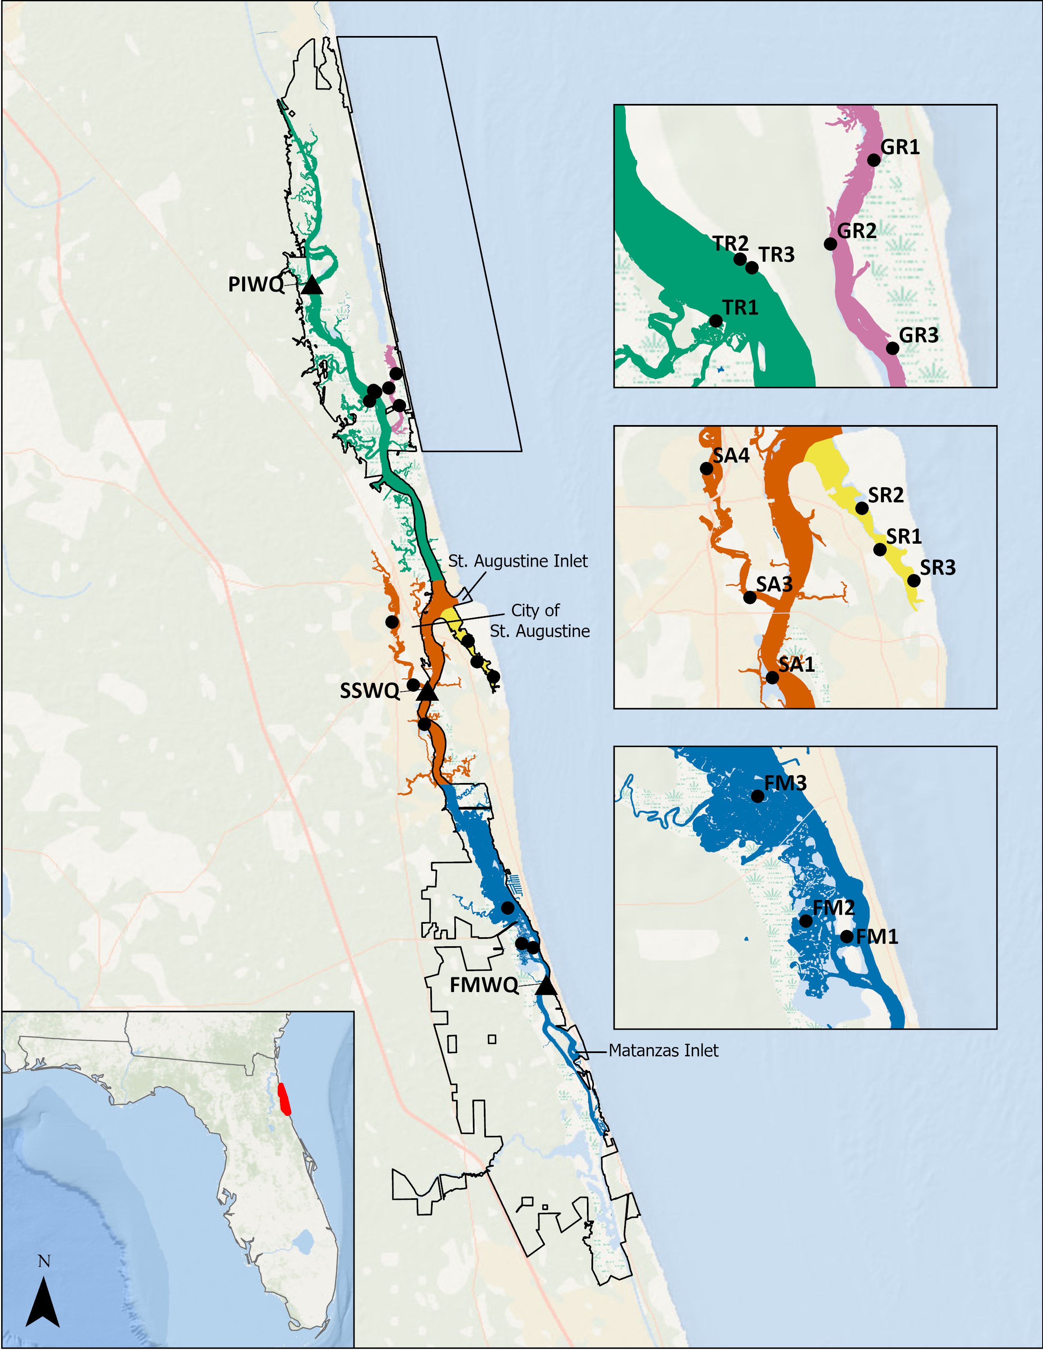

**Figure 1.** Map of the Guana Tolomato Matanzas National Estuarine Research Reserve boundary (black line, bottom inset: red), spat collector locations (black dots), water quality monitoring stations (black triangles, not included in insets), and regions: Tolomato River (turquoise), Guana River (pink), Salt Run (yellow), St. Augustine (red), and Fort Matanzas (blue). Water quality stations are from the System-Wide Monitoring Program and are Pine Island (“PIWQ”), San Sebastian (“SSWQ”), and Fort Matanzas (“FMWQ”).

The GTM National Estuarine Research Reserve (GTMNERR) initiated a monitoring program for local oysters in 2014 in which a regional approach was adopted based on perceived differences in water quality, food availability, hydrodynamics, harvesting, and management (Marcum et al. 2018). Regions were created based on the major waterways along the Atlantic Intracoastal Waterway (ICW): Tolomato River, Guana River, Salt Run and Matanzas River. A similar approach was used in this study; however, the Matanzas River region was further subdivided into St. Augustine (the northern portion of the river) and Fort Matanzas (the remaining portion of the river to the south) due to hydrological differences associated with the two inlets (Figure 1). Additionally, the GTMNERR maintains continuous long-term water quality monitoring stations within the GTM estuary as part of the System-Wide Monitoring Program (SWMP) of the National Estuarine Research Reserves (NERRS). Data from these stations was used to examine relationships in spat settlement with environmental conditions. All SWMP data are publicly available through the NERRS Centralized Data Management Office (CDMO) webpage (NERRS 2022).

2.2. Data Collection

2.2.1. Spat Tree Deployment

A stratified random sample of three reefs in each region of interest (except for the Tolomato River) were selected to deploy spat collectors. The Tolomato River region had two spat collectors deployed at either end of an oyster enhancement area known as Wright’s Landing, where 275 m2 of oyster reefs (28 individual reefs) were created from bagged shell in 2012 and 2013, and one across from the site on a natural reef. In June 2016 and June 2020, one additional spat collector was deployed in the St. Augustine and Tolomato regions, respectively.

Patterns in spat settlement were monitored using the hanging shell method. Samples were collected using T-shaped structures (trees) made from PVC, with shell “stringers” suspended from each side of the crossbar (Figure; Arnold et al. 2008, Haven and Fritz 1985, Parker 2015, Volety and Savarese 2001, Wilson et al. 2005). Each stringer was composed of six cleaned eastern oyster shells that were between 5 to 10 cm in shell height. Holes were drilled through the shells, and they were strung onto galvanized wire oriented with the inner concave surface facing down. Prior to deployment, shells were cleaned by soaking in bleach water for 48 hours followed by removal of all fouling organisms by scrubbing with a wire brush. After bleaching, the shells were then soaked for at least 24 hours in freshwater as a rinse.

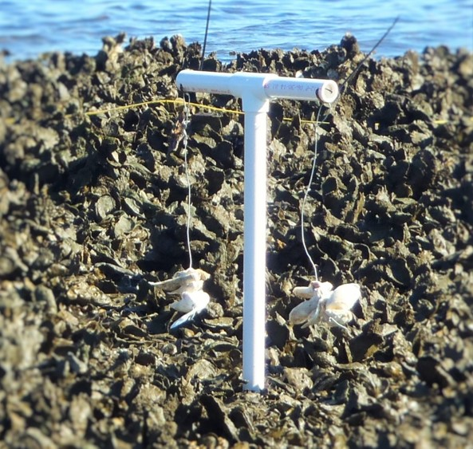

**Figure 2.** An example of a spat tree deployed on an oyster reef.

Trees were inserted into the reef at the apparent densest portion of live oyster on the reef and situated so that the shells were at the approximate height of the surrounding live oysters. All regions had trees deployed starting in February 2015 except for the Tolomato River, which was initiated in September 2015. These trees were left to soak for approximately one month upon which they were collected. During collection, any fouling organisms were removed from the tree, and new stringers were deployed. The retrieved stringers were labeled and stored in a -4°C freezer until processed. Efforts were made for the stringers to remain deployed for one month, however due to logistics, there was some variation in how long they were left in the field before collection. Trees were deployed for approximately 30 days on average with a range in the project of 21-43 days. Hurricane Matthew affected the study area in October 2016 and spat trees were unable to be collected, resulting in missing data from September and October of that year. The longest deployment was during January 2017 and was due to logistics associated with access to the trees.

2.2.2. Shell Processing and Counting

Shells were assigned numerical IDs based on their position on each stringer, with the topmost shell designated number one and the bottommost number six. The top and bottom shells (one and six, respectively) were discarded and shells two through five were evaluated for spat abundance.

In early years of the monitoring, spat were counted using the naked eye or a magnifying glass on both sides of the shells (interior and exterior). A small-scale comparison study determined that spat abundance was significantly higher using a dissection microscope and on the inner surface (bottom of the shell) only. Beginning in December 2017, all processing was done under microscope on the inner surface of the shells. A linear regression equation based on the comparison was developed to correct the non-microscope data for analysis:

|  |  |
| --- | --- |
| S = 1.4658*b* + 1.0378 | (1) |

where S was the adjusted number of spat counted and *b* was the observed number of spat counted on the bottom of the shell by naked eye. The average number of spat per shell was calculated for each tree deployed within each region each month. These values were then rounded to convert the number of spat to integers.

2.3 Water Quality

Water quality data used in this study were downloaded from the CDMO for the Pine Island (PIWQ), San Sebastian (SSWQ), and Fort Matanzas (FMWQ) stations for the continuous water quality information (Figure 1)(DATA CITATION). These stations were equipped with YSI EXO2 data sondes mounted to wooden pilings and deployed approximately one meter from the bottom. The sondes measure a variety of parameters every 15-minutes including water temperature (°C), salinity (psu), and turbidity (NTU). Discrete water samples were collected in duplicate at these same stations once a month for chlorophyll *a* (chl-*a,* µg/L*)* on a morning ebb tide from as close to the sonde depth as possible. Samples were filtered in the field, placed on ice in the dark and shipped overnight to the Florida Department of Environmental Protection’s Central Laboratory in Tallahassee, FL. Chl-*a* was extracted from frozen filters within 28 days and analyzed using spectrophotometry (SM10200H; citation).

The data had undergone the quality assurance and quality checks of the CDMO methods (CDMO MANUAL CITATION) and data flagged as “rejected” and “suspect” were removed from the dataset for analysis. The duplicate chl-*a* samples from each station were averaged by month. All water quality data was then further aggregated inside and outside the defined spat settlement periods for descriptive statistics.

2.4. Data Analysis

All data analysis and visualizations were created using R programming language (R Core Team, 2023). Several helpful import, filtering, and aggregating functions from the SWMPr package in R were used for the compilation of the water quality data (Beck 2016).

Since oyster count data has been shown to fit a negative binomial distribution, a generalized linear regression model with a negative binomial distribution was used to compare for differences in spat settlement per region and across years (Moore et al. 2020; Pine et al. 2023). Spat counts per shell were assumed to be related to the amount of time they were left “soaking” during deployment; therefore, to control for this the number of soak days was included as an effort offset (log link function; Zuur et al. 2013). This causes the models to predict the rate measured as count per deployment, while maintaining the dependent variable as an integer of counts. The dependent variable was the average spat count for each collector rounded as an integer. The independent variables (main effects) were both categorical and these were region and year. Multiple models were fitted to the data: Model 0 was the intercept only, Model 1 included region, Model 2 included region and the year, Model 3 included the interaction of region and year, and Model 4 included just year (Table 1).

Comparisons were made between models with different combinations of independent variables using Akaike’s Information Criterion (AICc). The lowest AICc value represents the best fit of the models tested (Table 1; Burnham and Anderson 2002). Models were fit to the data using the glmmTMB package (Brooks et al. 2017), assessed with the performance package (Lüdecke) and predicted values (marginal means) and pairwise comparisons with Tukey adjustments were made from the best fit model using the emmeans (Lenth 2024) package in R. The default glmmTMB optimizer (nlminb) was used. All data visualizations and summaries were performed using tidyverse functions in ggplot2 (Wickham 2016) and dplyr (Wickham).

3. Results

3.1. Spatial and Temporal Variability in Spat Settlement

Average annual spat settlement increased from the start of the project in 2015, reaching the highest regional averages in 2020 in all regions except Guana River (GR) (Figure 3). Peak settlement shifted from early summer in 2015 to late summer in 2017, which continued for the remainder of the monitoring. Timing of minor peaks appeared to forecast peak abundance: reefs with minor peaks that occurred later in the spring had higher spat abundance both during the fall peak as well as annually (Figure 3).

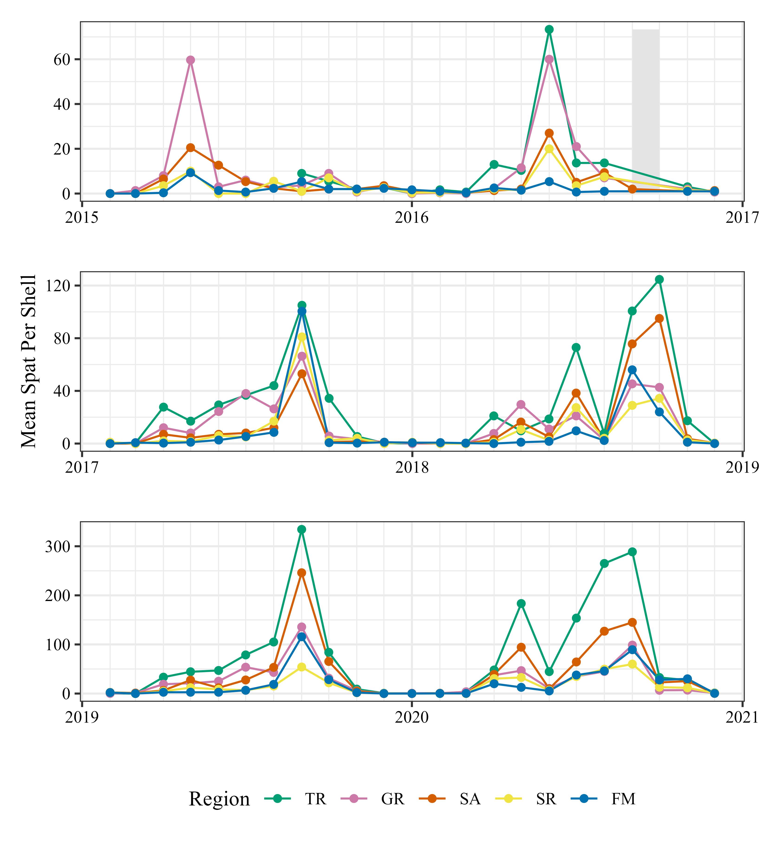

**Figure 3.** Monthly mean spat per shell for each region from 2015-2020 with panels broken up in two-year segments: Tolomato River (TR, green); Guana River (GR, pink); Saint Augustine (SA; orange); Salt Run (SR, yellow); and Fort Matanzas (FM, blue). Note the difference between the scales of the y-axis and missing data in the fall of 2016 due to Hurricane Matthew (September and October 2016) indicated by gray box in upper panel.

Five different models were fit to the spat per shell data (Table 1; Appendix). The best fitting model included terms for region and year. The dispersion ratio from the negative binomial distribution was 1.527 (*p* < 0.001), suggesting overdispersion. No significant interaction was found between year and regions; however, autocorrelation in the residuals was detected in the model (Kolmogorov-Smirnov test: *p* = 0.034, Durbin-Watson test: *p* < 0.001). Since the model results found significant patterns in region and year, comparisons were made using estimated marginal means and Tukey’s post-hoc tests to identify where those differences were found in the levels of each factor.

**Table 1.** Model selection table for generalized linear model of eastern oyster spat count data standardized by days left out in field for settlement on deployed collectors (“trees”) in different regions within the Guana Tolomato Matanzas estuary, Florida, USA. The predicted response is the average spat per shell per collector (spat_count). Akaike’s Information Criterion (AICc) and the AICc difference (ΔAICc) are provided to inform comparisons of the model statistical fit to the data (*k* is the number of parameters) and are ranked from lowest AICc to highest in the table. Region and year are both categorical variables in which region describes the location of the collection and year is the year of study. Soak_days is the amount of time in days that spat trees were deployed.

|  |  |  |  |  |  |  |
| --- | --- | --- | --- | --- | --- | --- |
| **Model** |  |  | ***k*** | **AICc** | Δ**AICc** | **AICc weight** |
| Model 2: spat_count ~ region + year + offset[log(soak_days)] |  |  | 11 | 6484.63 | 0.00 | 1 |
| Model 3: spat_count ~ region + year + region:year +  offset[log(soak_days)] |  |  | 31 | 6504.43 | 19.81 | 0 |
| Model 4: spat_count ~ year + offset[log(soak_days)] |  |  | 7 | 6559.31 | 74.69 | 0 |
| Model 1: spat_count ~ region + offset[log(soak_days)] |  |  | 6 | 6613.63 | 129.00 | 0 |
| Model 0: spat_count ~ offset[log(soak_days)] |  |  | 2 | 6688.57 | 203.94 | 0 |

Tolomato River (TR) had the greatest mean spat per shell (logarithmic-transformed estimated marginal mean [EMM]: 3.33, confidence interval [CI] = 3.09 – 3.58; untransformed mean: 43.11) and Fort Matanzas (FM) the least (EMM: 1.91, CI = 1.68 – 2.14; 9.97) (Figure 4A; Table 2). Variability in counts was also much higher in the TR region than all other regions and overall counts were significantly higher than all other regions. There was no difference found between GR (EMM: 2.77, CI = 2.54 – 3.00) and St. Augustine (SA; EMM: 2.63, CI = 2.39 – 2.86) and these regions were much higher than Salt Run (SR; EMM: 2.08, CI = 1.83 – 2.34) and FM (Figure 4A).

Spat settlement increased in all regions across the study period (Figure 2; Figure 4B). Between the first year (2015; EMM: 1.57, CI = 1.25 – 1.88) to the final year of the study (2020; 3.56, CI = 3.31 – 3.80), there was a 77.58% increase in the mean number of spat per shell. Both 2015 and 2016 (EMM: 1.73, CI = 1.44 – 2.01) were significantly lower than all the other years. The following two years 2017 (EMM: 2.41; CI = 2.15 – 2.66) and 2018 (EMM: 2.79; CI = 2.55 – 3.04) were higher, though not different from one another. Lastly, the final two years of the study, 2019 (EMM: 3.22; CI = 2.98 – 3.46) and 2020, had the highest counts per shell (Table 2).

**Table 2.** Estimated marginal means (EMM) for mean spat per shell in the five regions and between 2015-2020 in the Guana Tolomato Matanzas estuary. Results for regions are averaged over the levels of year and for years are averaged over the levels of region. All values are given on the log (not the response) scale. SE = standard error, CI = confidence level of 0.95.

|  |  |  |  |  |
| --- | --- | --- | --- | --- |
|  |  | **EMM** | **SE** | **CI** |
| Region | Tolomato River (TR) | 3.33 | 0.13 | 3.09 – 3.58 |
| Guana River (GR) | 2.77 | 0.12 | 2.54 – 3.00 |
| St. Augustine (SA) | 2.63 | 0.12 | 2.39 – 2.86 |
| Salt Run (SR) | 2.08 | 0.13 | 1.83 – 2.34 |
| Fort Matanzas (FM) | 1.91 | 0.12 | 1.68 – 2.14 |
| Year | 2015 | 1.57 | 0.16 | 1.25 – 1.88 |
| 2016 | 1.73 | 0.14 | 1.44 – 2.01 |
| 2017 | 2.41 | 0.13 | 2.15 – 2.66 |
| 2018 | 2.79 | 0.13 | 2.55 – 3.04 |
| 2019 | 3.22 | 0.13 | 2.98 – 3.46 |
| 2020 | 3.56 | 0.12 | 3.31 – 3.80 |

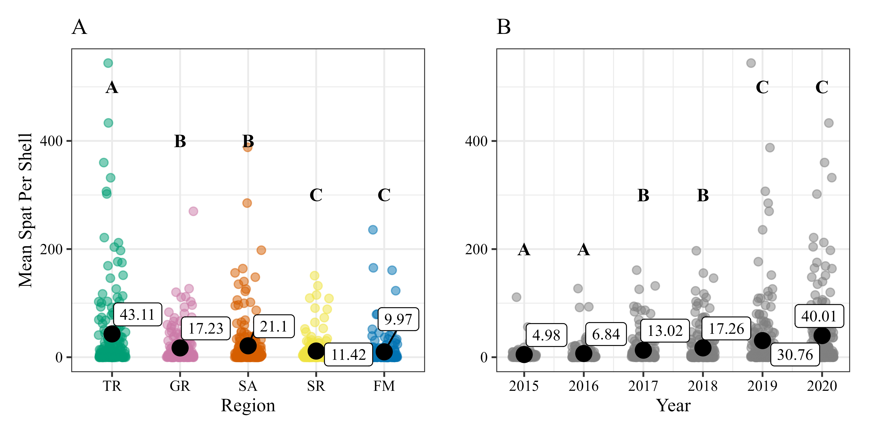

**Figure 4.** Mean spat per shell in the five regions (panel A) of the Guana Tolomato Matanzas estuary: Tolomato River (TR, green); Guana River (GR, pink); Saint Augustine (SA; orange); Salt Run (SR, yellow); and Fort Matanzas (FM, blue). Mean spat per shell in all regions for each year (panel B) of the study. Group means (raw and untransformed) are represented by the large black dots with the mean value presented in a call-out box next to the dot in each plot. Each point in the plots represents a sampled collector per month between 2015-2020. Letters indicate Tukey’s post-hoc test results and years/regions with differing letters are significant to each other (*p* < 0.001).

3.2. Patterns in Annual Spat Settlement

Overall, spat settlement appears to occur in all regions in the GTM estuary between April and November each year (Figure 5). Typically, a minor peak in settlement occurs in the mid-late spring and a much larger and regular peak occurs after the summer in September. All regions have more spat settlement between April – November than outside of this period (Table 3). For most regions, there is over 180% difference between spat settlement inside and outside of the settlement period. FM has the smallest difference between 313 (se = 110) average spat per year inside the settlement period and 26 (se = 14) outside the settlement period, but this difference is still well over 100%.

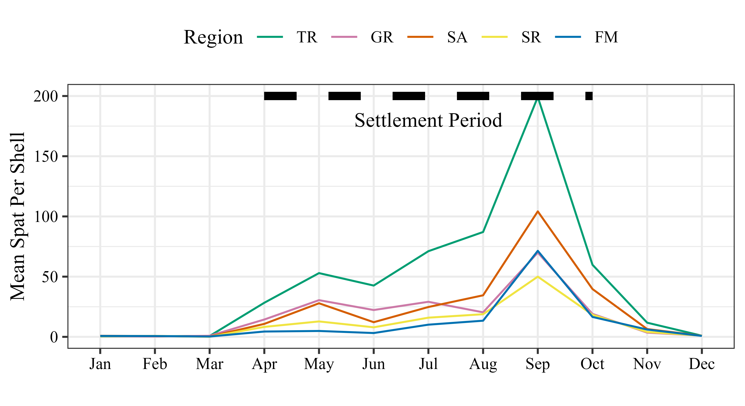

**Figure 5.** Monthly mean spat per shell with settlement period indicated as the thick dashed line between April and October for the five regions in the Guana Tolomato Matanzas estuary: Tolomato River (TR, green); Guana River (GR, pink); Saint Augustine (SA; orange); Salt Run (SR, yellow); and Fort Matanzas (FM, blue) based on data collected from 2015-2020.

**Table 3.** Summary information for spat settlement per shell in regions in the Guana Tolomato Matanzas estuary inside the annual settlement period (April – October) and outside of the settlement period (January – March and November – Dec). Metrics include average total settlement per shell per year (standard error) and average settlement per shell (standard error).

|  |  |  |  |  |
| --- | --- | --- | --- | --- |
|  | ***Avg. Total Settlement***  ***Per Shell Per Year*** | | ***Avg Settlement***  ***Per Shell*** | |
| **Region** | **Inside** | **Outside** | **Inside** | **Outside** |
| Tolomato River (TR) | 1234 (466) | 38 (13) | 75 (10) | 3 (1) |
| Guana River (GR) | 571 (18) | 18 (5) | 29 (4) | 2 **(**1) |
| St. Augustine (SA) | 677 (249) | 27 (11) | 35 (6) | 2 **(**1) |
| Salt Run (SR) | 305 (100) | 16 (5) | 19 (4) | 2 **(**1) |
| Fort Matanzas (FM) | 313 (110) | 26 (14) | 17 (4) | 2 **(**1) |

3.3. Drivers of Variability

Water quality varied across the six years of this study at all stations (Figure 6). Average monthly water temperatures were relatively consistent from year to year and among stations except for a cold snap in the winter between 2017 and 2018 (Figure 6A). There are differences in the salinity, turbidity, and chl-*a* regimes at all the sites with Pine Island (PI) having lower salinity and higher turbidity and chl-*a* than San Sebastian (SS) and Fort Matanzas (FM). There was a large peak in chl-*a* at FM in the spring of 2018 (Figure 6D). Turbidity appeared to be much higher between 2017-2019 (Figure 6C).

**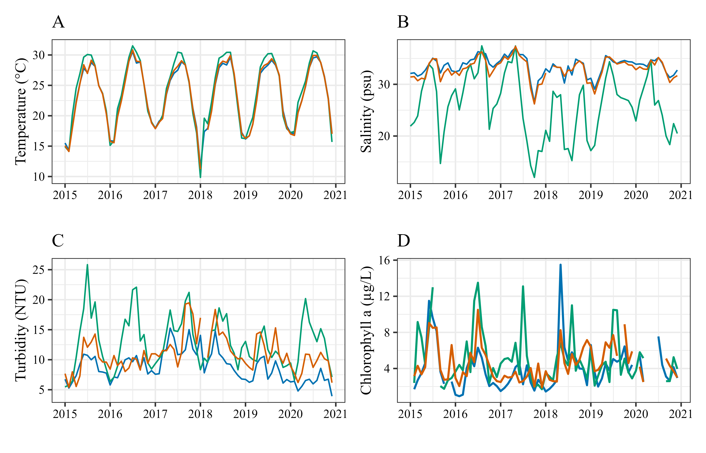

**Figure 6.** Monthly average water quality parameters at the Guana Tolomato Matanzas National Estuarine Research Reserve System-Wide Monitoring Program stations: Pine Island (PI, green), San Sebastian (SS, orange), and Fort Matanzas (FM, blue). Temperature (A), Salinity (B), and Turbidity (C) are all aggregated from 15-minute data from continuous instruments deployed at each site. Chlorophyll *a* (D) is collected monthly in duplicate at each station as a grab sample.

Examining monthly aggregated data revealed some distinctive patterns in water quality across the years and stations; however, further investigation into monthly minimum salinities (Figure 7A) and maximum turbidity (Figure 7B) revealed more distinctive patterns between years. Salinity at the stations that typically averaged more saline (FM and SS) fell well below 30 PSU in the early fall of 2017 and remained relatively low until 2020. There was also a sharp decrease in salinity at the FM station in the late summer of 2019. Monthly turbidity spikes were observed in the fall of 2016 and 2017, and in the early spring of 2020.

Water quality conditions were different within the settlement period (April – October) compared outside (January – March, November – December) the period (Table 4). Temperature, salinity, and chl-*a* are higher inside the period than outside. Turbidity patterns appear to show no differences associated with the months of spat settlement.

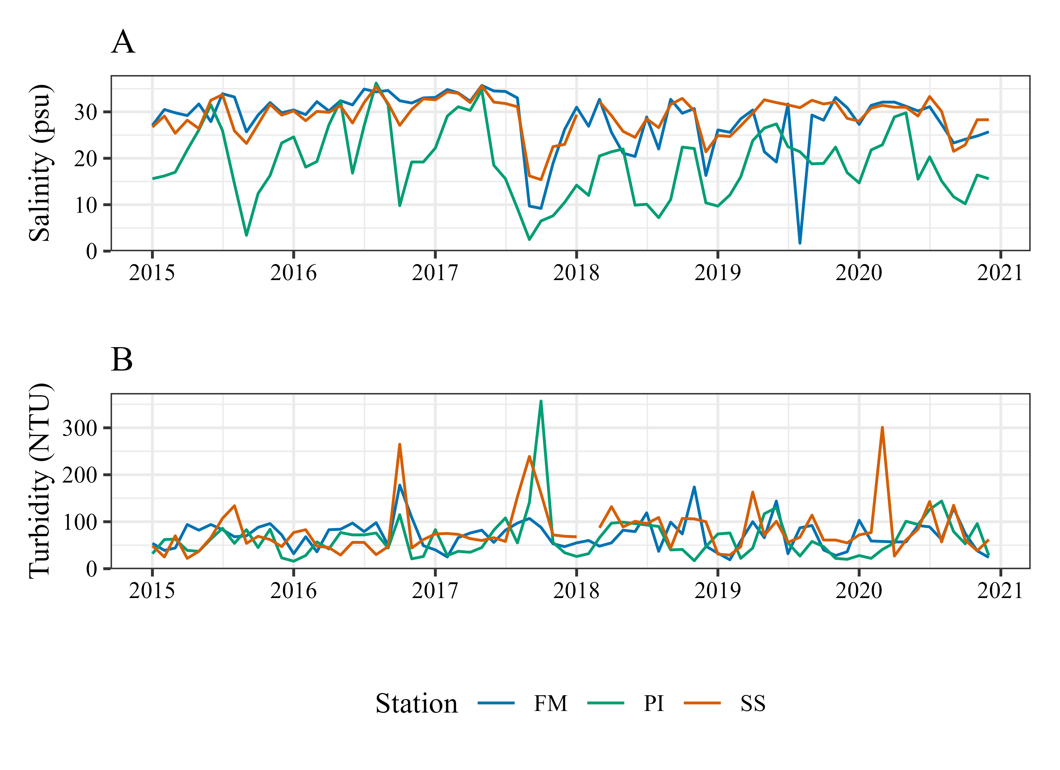

**Figure 7.** Water quality parameters at the Guana Tolomato Matanzas National Estuarine Research Reserve System-Wide Monitoring Program stations: Pine Island (PI, green), San Sebastian (SS, orange), and Fort Matanzas (FM, blue). (A) Monthly minimum salinity (PSU) and (B) monthly maximum turbidity (NTU) between 2015-2020.

**Table 4.** Summary statistics of water quality parameters collected from the Guana Tolomato Matanzas National Estuarine Research Reserve System-Wide Monitoring Program stations inside the spat settlement period (April – October) and outside of the settlement period (January – March, November – December). Temperature (Temp., Celsius), salinity (Sal., PSU), and turbidity (Turb., NTU) are calculated from 15-minute data from data sondes continuously deployed at each station. Chlorophyll *a* (Chl-*a*, µg/L) is collected monthly in duplicate at each station. All data is from the period of the study: January 2015 – December 2020. SE = standard error.

|  |  |  |  |  |  |  |  |  |  |
| --- | --- | --- | --- | --- | --- | --- | --- | --- | --- |
| **Station** |  | ***Inside Settlement Period*** | | | | ***Outside Settlement Period*** | | | |
|  | **Temp** | **Sal** | **Turb** | **Chl-*a*** | **Temp** | **Sal** | **Turb** | **Chl-*a*** |
| Pine Island | Mean  SE | 27.88  0.01 | 26.34  0.02 | 15.58  0.02 | 6.07  0.01 | 18.62  0.01 | 24.57  0.02 | 9.25  0.01 | 3.88  0.01 |
| Min | 18.1 | 2.5 | 2.0 | 1.75 | 7.1 | 7.6 | 0.0 | 1.7 |
| Max | 33.7 | 38.9 | 357.0 | 13.5 | 28.7 | 35.7 | 96.0 | 9.15 |
| San Sebastian | Mean  SE | 27.04  0.01 | 33.5  0.01 | 11.76  0.02 | 5.19  0.01 | 18.45  0.01 | 32.17  0.01 | 9.71  0.02 | 3.81  0.01 |
| Min | 17.1 | 15.4 | 0.0 | 2.0 | 8.6 | 21.4 | 1.0 | 1.9 |
| Max | 33.2 | 38 | 265.0 | 10.5 | 27.5 | 36.5 | 301.0 | 7.15 |
| Fort Matanzas | Mean  SE | 26.85  0.01 | 33.84  0.01 | 9.71  0.02 | 4.88  0.01 | 18.57  0.01 | 32.87  0.01 | 7.37  0.01 | 2.66  0.004 |
| Min | 17.5 | 1.7 | 1.0 | 1.55 | 8.2 | 16.3 | 1.0 | 0.93 |
| Max | 32.9 | 38.0 | 178.0 | 15.5 | 28.1 | 36.3 | 174.0 | 6.6 |

4. Discussion

Within the GTM estuary, there were differences between regions and across years in levels of spat settlement. The Tolomato River (TR) region consistently yielded the highest spat averages throughout the duration of this study. The TR region was established in September 2015 (seven months later than the other regions) and was initially one tree on a natural reef (TR1). Two more trees were installed in 2016 (TR2 and TR3); however, unlike trees deployed in the other regions of the project, these were deployed along an enhanced site, Wright’s Landing. Wright’s Landing was the site of an enhancement project by the GTMNERR and Northeast Florida Aquatic Preserves to establish a living shoreline of constructed oyster reefs and coconut fiber coir logs along the Guana Peninsula in 2013 to mitigate shoreline loss. Though the fiber coir logs failed within a few months following their installation (Dunnigan Thesis 2015), the constructed reefs, which were made of plastic mesh bags filled with oyster shells and stacked in 25-ft long segments along the shoreline, remained intact for a few years before some of the bags began to break open and release the oyster cultch across the sediment. It was along this shoreline in which the two trees were deployed to track spat settlement in 2016.

The settlement success was often higher in the trees deployed along the constructed reefs compared to the tree across the river in a natural oyster reef, leading to the high variation in the region over the course of the study. A fourth tree was deployed in 2020 within the natural reef area to further understand the counts between the enhanced site and natural reefs across the river, but the counts from this tree were left out of the analysis due to the short timeframe of its deployment. While the higher spat average at Wright’s Landing reefs could be indicative of artificial reef success, it is also possible that open exposure to water and lack of competing structure in the area influenced settlement rates as this bank of the shoreline did not have natural oyster reefs present prior to the installation of the constructed reefs. It is also possible that entrapment by a sandbar heavily influenced settlement rate. In addition to the installed artificial reef, this shoreline is also protected by a sandbar that protrudes out into the river along the length of the installation. This well-documented sandbar provides a protected anchorage basin along the river and for many years was the first place north of the St. Augustine Inlet to provide anchorage adjacent to arable land as evidenced by the long history of its use which dates back to the British Period as a plantation and a Second Spanish Period Minorcan farmstead. Evidence of these settlements still exist and are continued to be studied (Meide et al. 2010). It is unclear whether the presence of this sandbar, and its influence on the adjacent shoreline, was taken into consideration in the planning of the project at Wright’s Landing.

The differential flushing, tidal, and stratification regimes across regions make comparisons across field studies difficult, while emphasizing the importance of place-based studies to establish patterns. Oyster larvae are relatively weak swimmers and influenced by regional circulation patterns. Differences in spat settlement between two tributaries in the Chesapeake Bay in Maryland, USA, were found to likely be the result of different circulation patterns that exposed the less productive tributary to fewer larvae, no matter the source of their larvae (Kennedy and Krantz 1982). In addition to the TR region, the Saint Augustine (SA) region also had high rates of spat settlement in this study. Recent hydrodynamic studies of the GTM estuary characterized the regional residence times and the watershed in which the trees were deployed for the SA region with residence times exceeding 30 days (Gray et al. 2022). The TR region was also found to have a high residence, at 16.1 days. The high residence times of these regions could allow for longer periods of time for the oyster larvae suspended in the water column to settle compared to regions with shorter residence times.

Guana River (GR) and the northern portion of the Fort Matanzas (FM) region had the lowest residence times in the region (3.5-3.7 days) besides the St. Augustine Inlet (Gray et al. 2022). Unfortunately, the design of this spat settlement study did not take into account the presence of the tidal node, the meeting point where the tide turns between the St. Augustine and Matanzas Inlets, which exists around the Florida State Road 206 bridge. Though this node fluctuates north or south based on prevailing conditions at the time, this still hydrologically separates the FM region into two distinct water bodies, which was identified in previous studies (Gray et al. 2022) and used to differentiate the two estuarine nutrient regions in the Florida Statutes for waterbody assessments (citation). This study deployed the three spat trees around the 206 bridge (Figure 1) and therefore, it is unclear whether the trees adequately represented spat settlement in the region for this study.

SA and FM were found to have some of the highest densities of oysters during the GTMNERR pilot monitoring project in 2014-2016 (Marcum et al. 2018) but were found to have relatively low or the lowest spat settlement during this study. Spat settlement probability has been found to be higher on larger patches of reefs, but average settler densities are often higher on smaller patches (Fuchs and Reidenbach, 2013). Due to the quantity of oyster reefs in those regions, occupying a large spatial area, perhaps the settlement was lower on the collectors given the amount of other available space to settle. The higher counts found in the TR on the constructed reef locations could likely resemble the effect of smaller patch reefs as they were more isolated from the natural oyster reefs in the area, thus creating a “city in the desert” effect along that shoreline for spat settlement. Local harvesting practices also has the potential to increase alternative substrate for spat settlement. In the process of harvesting, harvesters break apart clusters of oysters to collect the legal-size oysters; therefore, exposing substrate, known as “cultch”, that is preferential for oyster larvae to settle on (Burrell 2003). However, it is also important to note that the spat tree collectors as a whole could also be underestimating settlement in regions as previous studies have found counts to be lower on collectors than adjacent natural reefs (Newell et al. 2000).

Although the full effect of harvesting on oyster densities has not been determined in this region, it has remained a concern particularly in the loss of available substrate, in areas such as Apalachicola Bay and Suwannee Sound (Camp et al. 2015; Pine et al. 2015; Kaufman, 2017). There are two conditionally approved areas for shellfish harvesting and four shellfish leases held in perpetuity within the GTM estuary (Dix et al. 2019; FDACS 2023). Although harvest has not been found to limit recruitment (NOAA 2007; FWC 2012; FWC 2013), the main regions with the heaviest oyster harvesting pressure are FM and Salt Run (SR). Given the low spat numbers in these regions and that the trees that yielded the highest average annual spat counts (TR and SA) were placed in zones where harvesting is prohibited, there may be some support for harvesting as a potential factor in driving differences in spat numbers across the GTM regions.

This study did not provide enough replication to quantify the effects of proximity to deep channels versus feeder creeks in spat settlement in the GTM estuary, however there were trees deployed within the regions in both types of habitats. The Wright’s Landing reefs, artificial and natural, were along the Atlantic Intracoastal Waterway (ICW) boating channel. And many of the FM trees are mostly sheltered from the boating channel, reducing wave action and therefore hydrodynamic stress. Boat wakes have been found to cause significant local damage and erosion of intertidal oyster reefs, particularly in northeast Florida where salt marshes and reefs have eroded to intertidal sand flats, impacting both established adult oysters and new recruits (Grizzle et al. 2002; Wall et al. 2005; Price 2005; Frazel 2009; Walters et al. 2017). The application of novel living shoreline designs to mitigate erosional effects associated with boat wakes and other high energy areas have been performed in the region with varying degrees of success but emphasize the impact of boat wakes along these shorelines (Herbert et al. 2018; Mathews et al. 2023). However, though detrimental to the existing habitats, oyster settlement has been found to increase with boating intensity, likely due to the increased tidal flow and potential larval supply in the boating channel, rather than the boat wakes themselves (Sussan and Charpentier, 2024). Predation rates have also been observed to be lower in areas of high boating activity due to hydrodynamic stress on predators (Freeman and Hamer, 2009). There have been signs of predation in the FM region and further south in Pellicer Flats (Marcum et al. 2018; Garland and Kimbro 2015).

Overall, spat settlement increased over the course of the study and peak settlement shifted from early to late summer. Reefs that experienced a minor peak in May as opposed to April tended to yield more spat per shell both annually and during the primary settlement period. Unfortunately, due to the severity of Hurricane Matthew, spat trees were not collected in September and October 2016 except for one tree (SA4) during September due to it being accessible by land. Except for the first year of the study (2015), all other years showed two peaks in spat settlement: a small peak that occurred in the spring and a large peak in late summer around September. It is unclear whether, given the period of missing data, this second and high peak in settlement reflected in later years would have also been observed in 2016. In general, oysters in more southern portions of their range exhibit longer spawning periods than their more northern counterparts (Kennedy 1996). Peak settlement in September has been found in North Carolina (Ortega and Sutherland 1992) and North Inlet, South Carolina (Kenny et al. 1990). The length of the settlement period in this study (April – November) was like other studies in similar latitudes along the southeastern United States and Gulf of Mexico which found peaks in both spring and late summer (Kenny et al. 1990; Moore and Trent 1971; Ingle 1951; Butler 1965; Arnold et al. 2008, O’Beirn et al. 1996, Parker 2015, Volety & Savarese 2001, Wilson et al. 2005).

Timing and duration of settlement in North Inlet, SC, has been found to be similar each year, but spatfall within years varied significantly (over a 5-year study period). There were also no consistent relationships between settlement intensity, late-stage larval density in the water column, water temperature, or salinity (Kenny et al. 1990). Over the course of the study, there were several climate events that took place that caused substantial environmental changes, potentially altering spat settlement patterns. During the six years of the study, three major hurricanes had an impact on the GTM estuary. In October 2016, Category 3 Hurricane Matthew passed 40 miles offshore of St. Augustine and dropped 34.5 cm of rainfall in the area as well as 1.6 meters of storm surge (Stewart 2016). The following year, Hurricane Irma (a Category 3 when it struck mainland Florida along the southwest coast) tracked up the center the state of Florida bringing large amounts of precipitation across the entire peninsular state in September 2017 dropping 26 cm of precipitation over St. Augustine (Cangialosi et al. 2018). Hurricane Dorian followed a similar track to Hurricane Matthew in September 2019, though farther off the coast. Hurricane Irma was also followed by a 5-day nor’easter in October 2017

Each of these tropical cyclones was observable to some degree within the water quality data collected by the continuous monitoring stations of the GTMNERR. The most influential of the storms appears to have been Hurricane Irma which caused persistent changes in water quality well into the next year. It was reported that 39% of the average DOC, 180% annual average ammonia-N, and 54% annual average orthophosphate were exported from Pellicer Creek, the largest source of freshwater in the GTM estuary, during the month of Hurricane Irma (Schaefer et al. 2022). Most hurricane nutrient transport is driven by “wet” hurricanes with high precipitation compared to windy, dry hurricanes (Paerl et al. 2018). This study found observable and persistent decreases in minimum salinities at all stations, particularly the more marine-influenced stations (SSWQ and FMWQ), following Hurricane Irma.

* High saline conditions before Hurricane Matthew, drought
* Turbidity:
  + Both Hurricane Matthew and Irma caused large spikes in turbidity.
  + PIWQ is more turbid than SSWQ and FMWQ outside of hurricanes.
  + To a lesser degree, turbidity of the water can affect larval growth as well as settlement. Larvae tend to settle on the underside of objects or in crevices, presumably to avoid light and silt, but have been found on the surfaces of objects in higher turbidity conditions (Kennedy, 1980; Nelson, 1953).
  + Large turbidity spike in early winter of 2020?
    - Hurricane Irma, in particular, caused persistent changes in water quality conditions well into the summer of 2018. *\*pull in information from Schaefer et al. 2022 and Brown et al. 2023\**
      * Peak in chl-*a* biomass at FM in spring 2018 (following Irma…upland draining, etc.)
    - There was a [cold snap in 2018](https://www.clickorlando.com/weather/2018/01/04/orlando-wakes-up-to-coldest-temps-in-nearly-4-years/)
      * *What do we know about oyster larvae and spawning in the area? Raabe and Gilg 2020 examined zooplankton patterns…. Anything from Todd and Jose Nunez??*
* Spawning response has been shown to be variable by the sex of the oyster (Galstoff, 1964), temperatures and salinity of the water (Ingle, 1952; Butler, 1949), and availability of food for adult oysters (Hofmann et al., 1992; Dekshenieks, 1993).. Lastly,
* Northeast Florida is an area undergoing increasing development (Kyzar et al. 2021), which is associated with decreased water quality conditions and increases in pollutants and sedimentation rates (Frazel 2009) affecting oyster populations. Coupled with the loss of oysters, upwards of 64% in the United States alone (zu Ermgassen et al. 2012), and effects of erosion and a changing climate, it is likely that we’ll see more enhancement projects for oysters in the future. In fact, the use of living shorelines to replace or supplement hardened shorelines to create habitat and facilitate migration upslope is a recommended management priority for the state of Florida (OIMMP).
* High energy systems: POSH (Mathews et al. 2023; Angelini project….)

5. Conclusions

Understanding the spatial and temporal patterns of spat settlement can help inform management to allow for informed restoration practices to maximize results. Spat in the Guana-Tolomato-Matanzas estuary settle between April and November with peak settlements typically occurring in September. Further investigation into timing of annual settlement and spring and late fall water quality conditions can provide insight into the role of climate-related events into oyster spawning and settlement patterns in an estuary along the eastern coast of the United States. Results of this study illustrate region- and year-specific variability in oyster settlement patterns and underscore the importance of local monitoring for oyster resource management, restoration, and research.

**Supplementary Materials:** The following supporting information can be downloaded at: www.mdpi.com/xxx/s1, Figure S1: title; Table S1: title; Video S1: title.

**Author Contributions:** Conceptualization, S.D.K. and H.J.P.; methodology, P.M., N.D.; validation, P.M., A.K. and S.D.K.; formal analysis, S.D.K.; investigation, P.M. and N.D.; resources, A.K.; data curation, P.M. and A.K.; writing—original draft preparation, S.D.K and H.J.P.; writing—review and editing, P.M., A.K., and N.D.; visualization, S.D.K.; supervision, P.M.; project administration, N.D.; funding acquisition, N.D. All authors have read and agreed to the published version of the manuscript.” Please turn to the [CRediT taxonomy](https://img.mdpi.org/data/contributor-role-instruction.pdf) for the term explanation. Authorship must be limited to those who have contributed substantially to the work reported.

**Funding:** Please add: “This research received no external funding” or “This research was funded by NAME OF FUNDER, grant number XXX” and “The APC was funded by XXX”. Check carefully that the details given are accurate and use the standard spelling of funding agency names at https://search.crossref.org/funding. Any errors may affect your future funding.

**Institutional Review Board Statement:** In this section, you should add the Institutional Review Board Statement and approval number, if relevant to your study. You might choose to exclude this statement if the study did not require ethical approval. Please note that the Editorial Office might ask you for further information. Please add “The study was conducted in accordance with the Declaration of Helsinki, and approved by the Institutional Review Board (or Ethics Committee) of NAME OF INSTITUTE (protocol code XXX and date of approval).” for studies involving humans. OR “The animal study protocol was approved by the Institutional Review Board (or Ethics Committee) of NAME OF INSTITUTE (protocol code XXX and date of approval).” for studies involving animals. OR “Ethical review and approval were waived for this study due to REASON (please provide a detailed justification).” OR “Not applicable” for studies not involving humans or animals.

**Data Availability Statement:** The data and analysis presented in this study are openly available in <https://github.com/skdunnigan/spat>. Water quality data from the National Estuarine Research Reserve System-Wide Monitoring Program is publicly available through the Centralized Data Management Office here: <https://cdmo.baruch.sc.edu>. Additional data on spat and oysters collected by the Guana Tolomato Matanzas National Estuarine Research Reserve are available upon request from the Research Director and corresponding author, Nikki Dix, as well as through the State of Florida Statewide Ecosystem Assessment of Coastal and Aquatic Resources Data Discovery Interface here: <https://data.florida-seacar.org/>.

**Acknowledgments:** In this section, you can acknowledge any support given which is not covered by the author contribution or funding sections. This may include administrative and technical support, or donations in kind (e.g., materials used for experiments).

**Savanna Mathis for mapping, many staff and volunteers of the GTMNERR which include but are not limited to Benjamin Mowbray, Mathew Monroe, Shannon Rininger, Jennifer Blythe Odzinski, Remo Mondazzi, Jeff Finnan?** Mike?

**Conflicts of Interest:** The authors declare no conflicts of interest. The funders had no role in the design of the study; in the collection, analyses, or interpretation of data; in the writing of the manuscript; or in the decision to publish the results.

**Appendix A**

The appendix is an optional section that can contain details and data supplemental to the main text—for example, explanations of experimental details that would disrupt the flow of the main text but nonetheless remain crucial to understanding and reproducing the research shown; figures of replicates for experiments of which representative data is shown in the main text can be added here if brief, or as Supplementary data. Mathematical proofs of results not central to the paper can be added as an appendix.

**Table 2.** This is a table. Tables should be placed in the main text near to the first time they are cited.

|  |  |  |  |
| --- | --- | --- | --- |
| **Title 1** |  | **Title 2** | **Title 3** |
| entry 1 |  | data | data |
| entry 2 |  | data | data 1 |

1 Tables may have a footer.

**Table 1.** Model results for the best-fitting generalized linear model (Table # in text) of oyster spat counts per shell on collectors deployed in five regions in the Guana Tolomato Matanzas estuary from 2015-2020 where spat count per shell = region + year + offset[log(soak time)]. Parameter estimates are on a log scale. Dispersion parameter 0.374.

|  |  |  |  |  |
| --- | --- | --- | --- | --- |
| **Parameter** | **Estimate** | **SE** | ***z*-value** | **Pr(>*z*)** |
| Intercept | -1.06 | 0.21 | -5.06 | < 0.001 |
| Guana River (GR) | -0.56 | 0.17 | -3.24 | < 0.01 |
| Saint Augustine (SA) | -0.71 | 0.17 | -4.12 | < 0.001 |
| Salt Run (SR) | -1.25 | 0.18 | -6.96 | < 0.001 |
| Fort Matanzas (FM) | -1.42 | 0.17 | -8.25 | < 0.001 |
| 2016 | 0.16 | 0.22 | 0.74 | 0.46 |
| 2017 | 0.84 | 0.21 | 4.07 | < 0.001 |
| 2018 | 1.23 | 0.21 | 5.95 | < 0.001 |
| 2019 | 1.65 | 0.2 | 8.12 | < 0.001 |
| 2020 | 1.99 | 0.21 | 9.70 | < 0.001 |

**Table 2a.** Pairwise comparisons of mean spat per shell between sampled regions in the Guana Tolomato Matanzas estuary: Tolomato River (TR), Guana River (GR), Saint Augustine (SA), Salt Run (SR), and Fort Matanzas (FM). Results are averaged over the level of year and given on the log (not the response) scale. Tukey method for post-hoc tests. SE = standard error.

|  |  |  |  |  |
| --- | --- | --- | --- | --- |
| **Contrast** | **Estimate** | **SE** | ***z*-ratio** | ***p*-value** |
| TR – GR | 0.56 | 0.17 | 3.24 | 0.0105 |
| TR – SA | 0.71 | 0.17 | 4.12 | 0.0004 |
| TR – SR | 1.25 | 0.18 | 6.96 | < 0.0001 |
| TR – FM | 1.43 | 0.17 | 8.25 | < 0.0001 |
| GR – SA | 0.14 | 0.17 | 0.85 | 0.916 |
| GR – SR | 0.69 | 0.18 | 3.90 | 0.0009 |
| GR – FM | 0.86 | 0.17 | 5.12 | < 0.0001 |
| SA – SR | 0.54 | 0.18 | 3.12 | 0.0162 |
| SA – FM | 0.72 | 0.17 | 4.30 | 0.0002 |
| SR – FM | 0.18 | 0.18 | 0.998 | 0.8565 |

**Table 2b.** Pairwise comparisons of mean spat per shell among sampling years in the Guana Tolomato Matanzas estuary. Results are averaged over the levels of region and given on the log (not the response) scale. Tukey method for post-hoc tests. SE = standard error.

|  |  |  |  |  |
| --- | --- | --- | --- | --- |
| **Parameter** | **Estimate** | **SE** | ***z*-value** | **Pr(>*z*)** |
| 2015 – 2016 | -0.16 | 0.22 | -0.74 | 0.9775 |
| 2015 – 2017 | -0.84 | 0.21 | -4.07 | 0.0007 |
| 2015 – 2018 | -1.23 | 0.21 | -5.95 | < 0.0001 |
| 2015 – 2019 | -1.65 | 0.20 | -8.12 | < 0.0001 |
| 2015 – 2020 | -1.99 | 0.21 | -9.70 | < 0.0001 |
| 2016 – 2017 | -0.68 | 0.19 | -3.52 | 0.0057 |
| 2016 – 2018 | -1.07 | 0.19 | -5.55 | < 0.0001 |
| 2016 – 2019 | -1.49 | 0.19 | -7.88 | < 0.0001 |
| 2016 - 2020 | -1.83 | 0.19 | -9.59 | < 0.0001 |
| 2017 – 2018 | -0.38 | 0.18 | -2.12 | 0.2745 |
| 2017 - 2019 | -0.81 | 0.18 | -4.53 | 0.0001 |
| 2017 – 2020 | -1.15 | 0.18 | -6.39 | < 0.0001 |
| 2018 - 2019 | -0.42 | 0.18 | -2.40 | 0.1572 |
| 2018 - 2020 | -0.76 | 0.18 | -4.31 | 0.0002 |
| 2019 - 2020 | -0.34 | 0.17 | -1.96 | 0.3635 |

**Appendix B**

All appendix sections must be cited in the main text. In the appendices, Figures, Tables, etc. should be labeled starting with “A”—e.g., Figure A1, Figure A2, etc.

References

References must be numbered in order of appearance in the text (including citations in tables and legends) and listed individually at the end of the manuscript. We recommend preparing the references with a bibliography software package, such as EndNote, ReferenceManager or Zotero to avoid typing mistakes and duplicated references. Include the digital object identifier (DOI) for all references where available.

Citations and references in the Supplementary Materials are permitted provided that they also appear in the reference list here.

In the text, reference numbers should be placed in square brackets [ ] and placed before the punctuation; for example [1], [1–3] or [1,3]. For embedded citations in the text with pagination, use both parentheses and brackets to indicate the reference number and page numbers; for example [5] (p. 10), or [6] (pp. 101–105).

1. Marine and Coastal Ecosystems and Human Well-being: A Synthesis Report Based on the Findings of the Millennium Ecosystem Assessment; United Nations Environmental Programme
2. Barbier, E.B. Valuing Ecosystem Services as Productive Inputs. *Economic Policy* **2007**, 22, 178–229, doi:10.1111/j.1468-0327.2007.00174.x.
3. Valiela, I.; Bowen, J.L.; York, J.K. Mangrove Forests: One of the World’s Threatened Major Tropical Environments. *BioScience* **2001**, *51*, 807, doi:[10.1641/0006-3568(2001)051[0807:MFOOTW]2.0.CO;2](https://doi.org/10.1641/0006-3568(2001)051%5b0807:MFOOTW%5d2.0.CO;2).
4. Orth, R.J.; Carruthers, T.J.B.; Dennison, W.C.; Duarte, C.M.; Fourqurean, J.W.; Heck, K.L.; Hughes, A.R.; Kendrick, G.A.; Kenworthy, W.J.; Olyarnik, S.; et al. A Global Crisis for Seagrass Ecosystems. *BioScience* **2006**, 56, 987, doi:10.1641/0006-3568(2006)56[987:AGCFSE]2.0.CO;2.
5. Ecosystems and Human Well-Being: Synthesis; Millennium Ecosystem Assessment (Program), Ed.; Island Press: Washington, DC, 2005; ISBN 978-1-59726-040-4.
6. FAO. *The State of World Fisheries and Aquaculture 2020*; FAO: Rome, Italy, 2020; ISBN 978-92-5-132692-3.
7. Beck, M.W.; Brumbaugh, R.D.; Airoldi, L.; Carranza, A.; Coen, L.D.; Crawford, C.; Defeo, O.; Edgar, G.J.; Hancock, B.; Kay, M.C.; et al. Oyster Reefs at Risk and Recommendations for Conservation, Restoration, and Management. *BioScience* 2011, 61, 107–116, doi:10.1525/bio.2011.61.2.5.
8. Worm, B.; Barbier, E.B.; Beaumont, N.; Duffy, J.E.; Folke, C.; Halpern, B.S.; Jackson, J.B.C.; Lotze, H.K.; Micheli, F.; Palumbi, S.R.; et al. Impacts of Biodiversity Loss on Ocean Ecosystem Services. *Science* **2006**, *314*, 787–790, doi:10.1126/science.1132294.
9. Scyphers, S.B.; Powers, S.P.; Heck, K.L.; Byron, D. Oyster Reefs as Natural Breakwaters Mitigate Shoreline Loss and Facilitate Fisheries. *PLoS ONE* 2011, 6, e22396, doi:10.1371/journal.pone.0022396.
10. Whalen, L.; Kreeger, D.; Bushek, D.; Moody, J.; Padeletti, A. Practioner’s Guide: Shellfish-Based Living Shorelines for Salt Marsh Erosion Control and Environmental Enhancement in the Mid-Atlantic; Partnership for the Delaware Estuary, Report #11-04, 2011; p. 48.
11. Kreeger, D.A.; Padeletti, A. Monitoring and Assessment of Representative Tidal Wetlands of the Delaware Estuary; Partnership for the Delaware Estuary, Report #13-03. 144 p.
12. Brumbaugh, R.D.; Beck, M.W.; Coen, L.D.; Craig, L.; Hicks, P. A Practitioner’s Guide to the Design and Monitoring of Shellfish Restoration Projects. 2006.
13. Walters, L.J.; Donnelly, M.J.; Sacks P.; Campbell D. Lessons learned from living shoreline stabilization in popular tourist areas: boat wakes, volunteer support, and protecting historic structures. In: *Living shorelines: the science and management of nature-based coastal protection.* Bilkovic, D.M.; Mitchell, M.M.; La Peyre, M.K.; Toft, J.D., Eds.; *CRC Marine Science Series*, CRC Press, Taylor & Francis Group: Boca Raton, FL, USA, 2017, pp. 233-246.
14. Rupasinghe, M.; Nicolas, R.S.; Lanham, B.S.; Morris, R.L. Sustainable Oyster Shell Incorporated Artificial Reef Concrete for Living Shorelines. *Construction and Building Materials* **2024**, 410, 134217, doi:10.1016/j.conbuildmat.2023.134217.
15. Rodriguez, A.B.; Fodrie, F.J.; Ridge, J.T.; Lindquist, N.L.; Theuerkauf, E.J.; Coleman, S.E.; Grabowski, J.H.; Brodeur, M.C.; Gittman, R.K.; Keller, D.A.; et al. Oyster Reefs Can Outpace Sea-Level Rise. *Nature Clim Change* **2014**, *4*, 493–497, doi:10.1038/nclimate2216.
16. Gittman, R.K.; Popowich, A.M.; Bruno, J.F.; Peterson, C.H. Marshes with and without Sills Protect Estuarine Shorelines from Erosion Better than Bulkheads during a Category 1 Hurricane. *Ocean & Coastal Management* **2014**, *102*, 94–102, doi:10.1016/j.ocecoaman.2014.09.016.
17. Dame, R.F. Ecology of marine bivalves: an ecosystem approach*.* CRC Marine Science Series, Boca Raton, FL, USA, 1996, 254 pp.
18. Grabowski, J.H.; Brumbaugh, R.D.; Conrad, R.F.; Keeler, A.G.; Opaluch, J.J.; Peterson, C.H.; Piehler, M.F.; Powers, S.P.; Smyth, A.R. Economic Valuation of Ecosystem Services Provided by Oyster Reefs. *BioScience* **2012**, *62*, 900–909, doi:[10.1525/bio.2012.62.10.10](https://doi.org/10.1525/bio.2012.62.10.10).
19. Gmelin, J.F*. Systema Naturae per Regna Tria Naturae, Secundum Classes, Ordines, Genera, Species, cum Characteribus, Differentiis, Synonymis, locis.* 12th ed.; G.E. Beer, Liepzig, Germany.1791; 3021-3909.
20. Radabaugh, K.R.; Geiger, S.P.; Moyer, R.P. *Oyster Integrated Mapping and Monitoring Program Report for the State of Florida*. Florida Fish and Wildlife Research Institute: St. Petersburg, FL, USA, **2019**, *22* pp. 175.
21. Breitburg, D.C. Are three-dimensional structure and healthy oyster populations the keys to an ecologically interesting and important fish community? pp 239-250 in Luckenbach, M.W., Mann, R., and Wesson, J.A., eds., *Oyster Reef Habitat Restoration: A Synopsis and Synthesis of Approaches*. Virginia Institute of Marine Science Press, Gloucester Pt., VA, USA, 1999; 358pp.
22. Coen, L.D.; Luckenbach, M.W. Developing Success Criteria and Goals for Evaluating Oyster Reef Restoration: Ecological Function or Resource Exploitation? *Ecological Engineering* **2000**, 15, 323–343, doi:10.1016/S0925-8574(00)00084-7.
23. Harding, J.; Mann, R.L. Influence of Habitat on Diet and Distribution of Striped Bass (Morone Saxatilis) in a Temperate Estuary. *Bulletin of Marine Science* **2003**, *72*.
24. Grabowski, J.H.; Hughes, A.R.; Kimbro, D.L.; Dolan, M.A. How Habitat Setting Influences Restored Oyster Reef Communities. *Ecology* **2005**, *86*, 1926–1935, doi:10.1890/04-0690.\
25. Tolley, S.G.; Volety, A.K. The Role of Oysters in Habitat Use of Oyster Reefs by Resident Fishes and Decapod Crustaceans. *Journal of Shellfish Research* **2005**, *24*, 1007–1012, doi:10.2983/0730-8000(2005)24[1007:TROOIH]2.0.CO;2.
26. Boudreaux, M.L.; Stiner, J.L.; Walters, L.J. Biodiversity of Sessile and Motile Macrofauna on Intertidal Oyster Reefs in Mosquito Lagoon, Florida. *Journal of Shellfish Research* **2006**, *25*, 1079–1089, doi:10.2983/0730-8000(2006)25[1079:BOSAMM]2.0.CO;2.
27. Rodney, W.S.; Paynter, K.T. Comparisons of Macrofaunal Assemblages on Restored and Non-Restored Oyster Reefs in Mesohaline Regions of Chesapeake Bay in Maryland. *Journal of Experimental Marine Biology and Ecology* **2006**, *335*, 39–51, doi:10.1016/j.jembe.2006.02.017.
28. zu Ermgassen, P.S.E.; Grabowski, J.H.; Gair, J.R.; Powers, S.P. Quantifying Fish and Mobile Invertebrate Production from a Threatened Nursery Habitat. *Journal of Applied Ecology* **2016**, *53*, 596–606, doi:[10.1111/1365-2664.12576](https://doi.org/10.1111/1365-2664.12576).
29. Grabowski, J.H.; Peterson, H.P. Restoring Reefs to Recover Ecosystem Services. In: *Ecosystem Engineers: Plants to Protists.* Cuddington, K., Byers, J.E., Wilson, W.G., Hastings, A., Eds.; Academic Press: Burlington, MA, USA, 2007; p. 281-298.
30. Booth, D.; Heck, K. Effects of the American Oyster *Crassostrea Virginica* on Growth Rates of the Seagrass *Halodule Wrightii*. *Mar. Ecol. Prog. Ser.* **2009**, 389, 117–126, doi:10.3354/meps08163.
31. Kellogg, M.L.; Smyth, A.R.; Luckenbach, M.W.; Carmichael, R.H.; Brown, B.L.; Cornwell, J.C.; Piehler, M.F.; Owens, M.S.; Dalrymple, D.J.; Higgins, C.B. Use of Oysters to Mitigate Eutrophication in Coastal Waters. *Estuarine, Coastal and Shelf Science* **2014**, 151, 156–168, doi:10.1016/j.ecss.2014.09.025.
32. Volety, A.K.; Haynes, L.; Goodman, P.; Gorman, P. Ecological Condition and Value of Oyster Reefs of the Southwest Florida Shelf Ecosystem. *Ecological Indicators* **2014**, *44*, 108–119, doi:10.1016/j.ecolind.2014.03.012.
33. Walles, B.; Salvador de Paiva, J.; van Prooijen, B.C.; Ysebaert, T.; Smaal, A.C. The Ecosystem Engineer Crassostrea Gigas Affects Tidal Flat Morphology Beyond the Boundary of Their Reef Structures. *Estuaries and Coasts* **2015**, 38, 941–950, doi:10.1007/s12237-014-9860-z.
34. Coen, L.D.; Brumbaugh, R.D.; Bushek, D.; Grizzle, R.; Luckenbach, M.W.; Posey, M.H.; Powers, S.P.; Tolley, S.G. Ecosystem Services Related to Oyster Restoration. *Marine Ecology Progress Series* **2007**, 341, 303–307, doi:10.3354/meps341303.
35. Galstoff, P.S. The American Oyster *Crassostrea virginica* Gmelin. *Fishery Bulletin of the Fish and Wildlife Service.* **1964**, *164*, 297-380.
36. Kennedy, V.S. Biology of larvae and spat. In: *The eastern oyster: Crassostrea virginica.* Kennedy, V.S., Newell, R.I.E., Eble, A.F., Eds.; Maryland Sea Grant College: College Park, MD, USA, 1996; p. 371-421.
37. Nelson, T.C.; Perkins, E.B. Annual report of the Department of Biology for the year ending June 30, 1930. 1931, N. J. Agr. Exp. Sta. p. 1-47.
38. Nelson, T.C. Observations of the behavior and distribution of oyster larvae. *Proc. Natl. Shellfish. Assoc.* **1953**, 43, 99-104.
39. Kennedy, V.S. Comparison of recent and past patterns of oyster settlement and seasonal fouling in Broad Creek and Tred Avon River, Maryland. *Pro. Natl. Shellfish. Assoc.* **1980**, *70*, 36-46.
40. Underwood, A.J.; Fairweather, P.G. Supply-Side Ecology and Benthic Marine Assemblages. *Trends in Ecology & Evolution* **1989**, *4*, 16–20, doi:10.1016/0169-5347(89)90008-6.
41. Michener, W.K.; Kenny, P.D. Spatial and Temporal Patterns of Crassostrea Virginica (Gmelin) Recruitment: Relationship to Scale and Substratum. *Journal of Experimental Marine Biology and Ecology* **1991**, *154*, 97–121, doi:10.1016/0022-0981(91)90077-A.
42. Hoese, H. D.; Nelson, W. R.; Beckert, H. Seasonal and spatial setting of fouling organisms in Mobile Bay and eastern Mississippi Sound, Alabama. *Alabama Marine Resources Bulletin* **1972**, *8*, 9-17.
43. Lee, C. Seasonal and spatial study of oyster spat in Mobile Bay and East Mississippi Sound. PhD Dissertation, University of South Alabama, Mobile, AL, 1979.
44. Kenny, P.D.; Michener, W.K.; Allen, D.M. Spatial and temporal patterns of oyster settlement in a high salinity estuary. *J. Shellfish Res.* **1990**, *9*, 133-140.
45. Saoud, I.G.; Rouse, D.B.; Wallace, R.K.; Howe, J.; Page, B. Oyster Crassostrea Virginica Spat Settlement as It Relates to the Restoration of Fish River Reef in Mobile Bay, Alabama. *Journal of the World Aquaculture Society* **2000**, *31*, 640–650, doi:10.1111/j.1749-7345.2000.tb00914.x.
46. Kim, C.; Park, K.; Powers, S.P.; Graham, W.M.; Bayha, K.M. Oyster Larval Transport in Coastal Alabama: Dominance of Physical Transport over Biological Behavior in a Shallow Estuary. *J. Geophys. Res.* **2010**, *115*, 2010JC006115, doi:10.1029/2010JC006115
47. Ingle, R.M.; Dawson, Jr., C.E. Growth of the American Oyster, *Crassostrea virginica* (Gmelin) in Florida Waters. *Bulletin of Marine Science* **1952,** *2*, 393-404.
48. Pine, W.E.; Brucker, J.; Davis, M.; Geiger, S.; Gandy, R.; Shantz, A.; Stewart Merrill, T.; Camp, E.V. Collapsed Oyster Populations in Large Florida Estuaries Appear Resistant to Restoration Using Traditional Cultching Methods—Insights from Ongoing Efforts in Multiple Systems. *Mar Coast Fish* **2023**, *15*, e10249, doi:[10.1002/mcf2.10249](https://doi.org/10.1002/mcf2.10249).
49. Dix, N. G. How Estuaries Respond to Nutrient Load: The Guana Tolomato Matanzas National Estuarine Research Reserve as a Model Case. National Estuarine Research Reserve Graduate Research Fellowship Final Report, 2009.
50. Marcum, P.; Dix, N.; Monroe, M. Guana Tolomato Matanzas National Estuarine Research Reserve 2014-2016 Oyster Monitoring Summary; Guana Tolomoto Matanzas National Estuarine Research Reserve, **2018**; p. 32.
51. Phlips, E.J.; Love, N.; Badylak, S.; Hansen, P.; Lockwood, J.; John, C.V.; Gleeson, R. A Comparison of Water Quality and Hydrodynamic Characteristics of the Guana Tolomato Matanzas National Estuarine Research Reserve and the Indian River Lagoon of Florida. *J. Coast. Res.* **2004**, *SI 45*, 93-109. doi:[10.2112/SI45-093.1](https://doi.org/10.2112/SI45-093.1).
52. Sheng, Y.P.; Tutak, B.; Davis, J.R.; Paramygin, V. Circulation and Flushing in the Lagoonal System of the Guana Tolomato Matanzas National Estuarine Research Reserve (GTMNERR), Florida. *J. Coast. Res.* **2008**, *10055*, 9-25. doi:[10.2112/SI55-002.1](https://doi.org/10.2112/SI55-002.1)
53. Gray, M.W.; Pinton, D.; Canestrelli, A.; Dix, N.; Marcum, P.; Kimbro, D.; Grizzle, R. Beyond Residence Time: Quantifying Factors that Drive the Spatially Explicit Filtration Services of and Abundant Native Oyster Population. *Estuaries and Coasts*. **2022**, *45*, 1343–1360, doi:[10.1007/s12237-021-01017-x](https://doi.org/10.1007/s12237-021-01017-x).
54. NOAA National Estuarine Research Reserve System (NERRS). System-Wide Monitoring Program Data Management Manual, v6.7. Centralized Data Management Office **2022**, 201. <https://cdmo.baruch.sc.edu>
55. NOAA National Estuarine Research Reserve System (NERRS). System-Wide Monitoring Program. Centralized Data Management Office. Available on <https://cdmo.baruch.sc.edu> (accessed on 31 January 2024)
56. Arnold, W.S.; Parker, M.L.; Stephenson, S.P. Oyster monitoring in the northern estuaries. Final report to the South Florida Wtaer Management District. *FWRI Reports,* 2008.
57. Haven, D.S.; Fritz, L.W. Settling of the American oyster *Crassostrea virginica* in the James River, Virginia, USA: temporal and spatial distribution. *Marine Biology* **1985**, *86*, 271-282.
58. Parker, M.L. Oyster Monitoring in the Northern Estuaries on the Southeast Coast of Florida, *Florida Fish and Wildlife Research Institute Final Report (2005-2014),* 2015.
59. Volety, A.K.; Savarese, M. Oysters as indicators of ecosystem health: determining the impacts of watershed alterations and implications for restoration. *Final Report submitted to National Life Foundation, South Florida Water Management District (Big Cypress Basin), and Florida Gulf Coast University Foundation*. 2001.
60. Wilson, C.; Scotto, L.; Scarpa, J.; Volety, A.; Laramore, S.; Haunert, D. Survey of Water Quality, Oyster Reproduction and Oyster Health Status in the St. Lucie Estuary. *J. Shellfish Res.* **2005**, 24, 157–165, doi:10.2983/0730-8000(2005)24[157:SOWQOR]2.0.CO;2.
61. LINE 181 DATA CITATION
62. Rice, E.W.; Baird, R.B.; Eaton, A.D.; Clesceri, L.S. 10200 Chlorophyll. In Standard Methods For The Examination of Water and Wastewater; American Public Health Association, American Water Works Association, Water Environment Federation: Port City Press, Baltimore, Maryland, 2012; p. 1496 ISBN 978-0-87553-013-0.
63. LINE 192 CDMO MANUAL CITATION
64. R Core Team. R: A Language and Environment for Statistical Computing. R Foundation for Statistical Computing: Vienna, Austria, 2023 (<https://www.R-project.org/>)
65. Beck, M.W. SWMPr: An R Package for Retrieving, Organizing, and Analyzing Environmental Data for Estuaries. *The R Journal* **2016***, 8,* 219-232. doi: [10.32614/RJ-2016-015](https://doi.org/10.32614/RJ-2016-015)
66. Moore, J.F.; Pine, W.E.; Frederick, P.C.; Beck, S.; Moreno, M.; Dodrill, M.J.; Boone, M.; Sturmer, L.; Yurek, S. Trends in Oyster Populations in the Northeastern Gulf of Mexico: An Assessment of River Discharge and Fishing Effects over Time and Space. *Mar Coast Fish* **2020**, *12*, 191–204, doi:[10.1002/mcf2.10117](https://doi.org/10.1002/mcf2.10117).
67. Zuur, A.F.; Hilbe, J.M.; Ieno, E.N. *A Beginner’s Guide to GLM and GLMM with R: A Frequentist and Bayesian Perspective for Ecologists*; Highland Statistics Ltd. book series; Highland Statistics Limited, **2013**; ISBN 978-0-9571741-3-9.
68. Burnham, K.P.; Anderson, D.R. Model Selection and Multimodel Inference: A Practical Information-Theoretic Approach; 2nd ed.; Springer: New York, NY, USA, 2002; pp. 488 ISBN 978-0-387-95364-9.
69. Brooks, M.E.; Kristensen, K.; van Benthem, K.J.; Magnusson, A.; Berg, C.W.; Nielsen, A.; Skaug, H.J.; Maechler, M.; Bolker, B.M. glmmTMB Balances Speed and Flexibility Among Packages for Zero-Inflated Generalized Linear Mixed Modeling. *The R Journal* **2017**, *9*, 378–400, doi:[10.32614/RJ-2017-066](https://doi.org/10.32614/RJ-2017-066).
70. Lüdecke, D.; Ben-Shachar, M.S.; Patil, I.; Waggoner, P.; Makowski, D. performance: An R Package for Assessment, Comparison and Testing of Statistical Models. *The J. of Open Source Sci.* **2021**, 6(60), 3139. doi: [10.21105/joss.03139](https://doi.org/10.21105/joss.03139)
71. Lenth, R. emmeans: Estimated Marginal Means, Aka Least-Squares Means. [R Package emmeans Version 1.10.0]. Available online: <https://CRAN.R-project.org/package=emmeans> (accessed on 02 February 2024)
72. Wickham, H. *ggplot2: Elegant Graphics for Data Analysis*. Springer-Verlag: New York, NY, USA. **2016**; ISBN: 978-3-319-24277-4
73. Wickham, H.; François, R.; Henry, L.; Müller, K.; Vaughan, D. dplyr: A Grammar of Data Manipulation. [R Package dplyr Version 1.1.4]. Available online: <https://CRAN.R-project.org/package=dplyr> (accessed on 02 February 2024)
74. Dunnigan, S.K. Habitat Value of Restored Intertidal Shoreline for Fish and Macrobenthic Communities in Northeast Florida. Master’s Thesis, University of North Florida, Jacksonville, Florida, USA, December 2015. *UNF Theses and Dissertations* Paper 597. <https://digitalcommons.unf.edu/etd/597>
75. Meide, C.; Turner, S. P.; Burke, B.P. 2007-2009 Investigations at the Tolomato Bar Anchorage, 8SJ3150 and 8SJ4801. *First Coast Maritime Archaeology Project 2007-2009: Report on Archaeological and Historical Investigations and Other Project Activities*, 2nd ed.; Lighthouse Archaeological Monitoring Program, Inc., **2010**: Saint Augustine, Florida, USA; pp. 259-291
76. Kennedy, V.S.; Krantz, L.B. Comparative Gametogenic and Spawning Patterns of the Oyster *Crassostrea virginica* (Gmelin) in Central Chesapeake Bay. *Journal of Shellfish Research* **1982**, 2, 133–140.
77. LINE 397 FLORIDA STATUES CITATION
78. Fuchs, H.L.; Reidenbach, M.A. Biophysical Constraints on Optimal Patch Lengths for Settlement of a Reef-Building Bivalve. *PLoS ONE* **2013**, 8, e71506, doi:10.1371/journal.pone.0071506.
79. Burrell, V.G., Jr. *South Carolina oyster industry: a history*. Charleston, SC: V.G. Burrell Publ., 2003, 67 pp.
80. Newell, R.I.E.; Alspach, G.S.; Jacobs, D.; Kennedy, V.S. Mortality of Newly Metamorphosed Eastern Oysters (*Crassostrea virginica*) in Mesohaline Chesapeake Bay. *Marine Biology* **2000**, 136, 665–676, doi:10.1007/s002270050726.
81. Dix, N., L. Walters, E. Hernandez, A. Roddenberry, S. Garvis, M. Anderson & K. R. Radabaugh. 2019. Northeast Florida. In K. R. Radabaugh, R.P. Moyer & S. P. Geiger, editors. *Oyster Integrated Mapping and Monitoring Program Report for the State of Florida*. Fish and Wildlife Research Institute, Florida Fish and Wildlife Conservation Commission. FWRI Technical Report 22.
82. Stewart, S.R. *Hurricane Matthew*; National Hurricane Center: Miami, FL, USA, 2016.
83. Cangialosi, J.P.; Latto, A.S.; Berg, R. *National Hurricane Cetner Tropical Cyclone Report*; National Hurricane Center: Miami, FL, USA, 2018.
84. Paerl, H.W.; Crosswell, J.R.; Van Dam, B.; Hall, N.S.; Rossignol, K.L.; Osburn, C.L.; Hounshell, A.G.; Sloup, R.S.; Harding, L.W., Jr. Two Decades of Tropical Cyclone Impacts on North Carolina’s Estuarine Carbon, Nutrient and Phytoplankton Dynamics: Implications for Biogeochemical Cycling and Water Quality in a Stormier World. *Biogeochemistry* **2018**, *141*, 307-332 doi: 10.1007/s10533-018-0438-x
85. Dame, R.F. *Ecology of Marine Bivalves: An Ecosystem Approach*; Marine science series; 2nd ed.; CRC Press: Boca Raton, 2012; ISBN 978-1-4398-3909-6.
86. Butler, P.A. Gametogensis in the oyster under conditions of depressed salinity. *The Biological Bulletin* **1949**, *96*, 263-269.
87. Hofmannn, E.E.; Klinck, J. Modeling oyster populations. III. Critical feeding periods, growth and reproduction. *Journal of Shellfish Research* **1992**, *11*, 399-416.
88. Dekshenieks, M.M.; Hofmann, E.E.; Powell, E.N. Environmental Effects on the Growth and Development of Eastern Oyster, Crassostrea Virginica (Gmelin, 1791), Larvae: A Modeling Study. *Journal of Shellfish Research* **1993**, *12*, 241–254.
89. Nelson, T. C. Some scientific aids to the oyster industry. *American Scientist* **1957**, *45*, 301-332.
90. Turley, B.; Reece, K.; Shen, J.; Lee, J.-H.; Guo, X.; McDowell, J. Multiple Drivers of Interannual Oyster Settlement and Recruitment in the Lower Chesapeake Bay. *Conserv Genet* **2019**, *20*, 1057–1071, doi:10.1007/s10592-019-01194-0.
91. Sussan, T.T.; Charpentier, C.L. Conditions That Promote Oyster Settlement Coincide with Areas of High Boating Activity in a Developed Coastal Habitat. Journal of Experimental Marine Biology and Ecology 2024, 572, 151989 doi:10.1016/j.jembe.2024.151989.
92. Whitman, E.R.; Reidenbach, M.A. Benthic Flow Environments Affect Recruitment of Crassostrea Virginica Larvae to an Intertidal Oyster Reef. Marine Ecology Progress Series 2012, 463, 177–191, doi:10.3354/meps09882.

EXAMPLES

1. Author 1, A.B.; Author 2, C.D. Title of the article. *Abbreviated Journal Name* **Year**, *Volume*, page range.
2. Author 1, A.; Author 2, B. Title of the chapter. In *Book Title*, 2nd ed.; Editor 1, A., Editor 2, B., Eds.; Publisher: Publisher Location, Country, 2007; Volume 3, pp. 154–196.
3. Author 1, A.; Author 2, B. *Book Title*, 3rd ed.; Publisher: Publisher Location, Country, 2008; pp. 154–196.
4. Author 1, A.B.; Author 2, C. Title of Unpublished Work. *Abbreviated Journal Name* year, *phrase indicating stage of publication (submitted; accepted; in press)*.
5. Author 1, A.B. (University, City, State, Country); Author 2, C. (Institute, City, State, Country). Personal communication, 2012.
6. Author 1, A.B.; Author 2, C.D.; Author 3, E.F. Title of Presentation. In Proceedings of the Name of the Conference, Location of Conference, Country, Date of Conference (Day Month Year).
7. Author 1, A.B. Title of Thesis. Level of Thesis, Degree-Granting University, Location of University, Date of Completion.
8. Title of Site. Available online: URL (accessed on Day Month Year).

**Disclaimer/Publisher’s Note:** The statements, opinions and data contained in all publications are solely those of the individual author(s) and contributor(s) and not of MDPI and/or the editor(s). MDPI and/or the editor(s) disclaim responsibility for any injury to people or property resulting from any ideas, methods, instructions or products referred to in the content.

1.